**KENYA CERTIFICATE OF SECONDARY EDUCATION**

**COMPUTER PROJECT 2024 (451/3)**

**NAME**: **NGOTHO MICHAEL WAHINYA**

**SCHOOL CODE:**  **27536148**

**INDEX NUMBER**: **149**

**PROJECT TITLE**: **UZIMA BOREHOLE DRILLING SYSTEM**

**YEAR OF EXAMINATION**: **2024**

**SCHOOL**:  **ANESTAR VICTORY BOYS**

KCSE

2024

# DECLARATION

## STUDENT’S DECLARATION

I Ngotho Michael Wahinya, assert that Uzima Borehole Drilling Database System for the Computer Studies Project has been done with utmost integrity, for the purpose of the Kenya National Examination. All sources of research that have led to the completion of the system have been well stated. I understand that there will be no tolerance towards academic dishonesty and thus affirms that the documentation as well as the Database have taken my individual work and knowledge from the subject. Any external sources referenced in this project have been appropriately. I am fully responsible for the presented work.

Signature: __________________________

Date: __________________________

## SUPERVISOR DECLARATION

I, Mr Makori, hereby declare that I have supervised and guided Ngotho Michael Wahinya in the development of the Uzima Borehole Drilling Database System for the Computer Studies Project. I have reviewed the project documentation, and implementation, and I affirm that the work presented is consistent with the guidelines and expectations of the KNEC. I believe that the student has demonstrated a sound understanding of the concepts and skills covered in the Computer Studies curriculum. I take responsibility for providing necessary guidance and support throughout the project's development.

Signature: __________________________

Date: __________________________

# DEDICATION

I dedicate this Computer Studies Project on the Uzima Company Borehole Services Database System to my parents for encouraging me all through as I was doing the project, my teacher for impacting me with the knowledge which enabled me to get done with the project easily and also to the school for providing us with the necessary materials needed for the completion of my Computer project.

# ACKNOWLEDGMENT

Firstly I would like to extend my gratitude to my teacher Mr for impacting me with knowledge that I used throughout this project and for guiding me through the project. Secondly, to thank my family and friends for helping me through any way possible to complete my project within the required time, and lastly to thank the school administration for their support throughout the computer project.

Contents

NAME i

SCHOOL CODE: i

INDEX NUMBER i

PROJECT TITLE i

YEAR OF EXAMINATION i

SCHOOL i

DECLARATION ii

STUDENT’S DECLARATION ii

SUPERVISOR DECLARATION ii

DEDICATION iii

ACKNOWLEDGMENT iv

LIST OF TABLES AND FIGURES viii

CHAPTER 1: INTRODUCTION 1

1.1 BACKGROUND INTRODUCTION 1

CHAPTER 2: SYSTEM ANALYSIS 1

2.1 PROBLEM DEFINITION 1

2.2 OVERVIEW OF THE EXISTING SYSTEM 1

2.2.1 SYSTEM STRUCTURE 3

2.3 OVERVIEW OF THE PROPOSED SYSTEM 3

2.3.1 SYSTEM OVERVIEW 3

2.3.2 OBJECTIVES OF THE PROPOSED SYSTEM 4

2.3.3 BENEFITS OF THE PROPOSED SYSTEM 5

2.3.4 DISADVANTAGES OF THE PROPOSED SYSTEM 6

2.3.5 SCOPE OF THE SYSTEM 7

2.3.6 COST AND BENEFITS ANALYSIS 8

2.4 FEASIBILITY STUDY 10

2.4.1 Economic Feasibility 10

2.4.2 Technical Feasibility 10

2.4.3 Operational Feasibility 10

2.4.4 Legal Feasibility 11

2.4.5 Schedule Feasibility 11

2.5 FACT FINDING 12

2.6 SUMMARY OF FACT-FINDING METHODS USED 13

2.7 SYSTEM REQUIREMENTS AND SPECIFICATIONS 13

CHAPTER 3: SYSTEM DESIGN 16

3.1 PRELIMINARY DESIGN 16

3.1.1 Overall System Flowchart 16

3.1.2 PROGRAM MODULE FLOWCHARTS 17

3.2DETAILED DESIGN 18

3.2.1 TABLES 18

3.2.2 INPUT DESIGN (FORMS) 20

3.2.3 OUTPUT DESIGN (REPORTS) 24

3.2.4 RELATIONSHIPS 27

3.1 GENERAL SYSTEM SECURITY 28

CHAPTER 4: SYSTEM CONSTRUCTION 29

4.1 DATABASE RELATIONSHIP DIAGRAM 29

4.2 ENFORCING INTERGRITY CONSTRAINTS 29

4.2.1 REFERENCIAL INTERGRITY 30

4.3 Database Tables 30

4.3.1 CLIENT’S TABLE 30

4.3.2 DRILLING APPLICATIONS 31

4.3.3 PLUMBING APPLICATIONS 31

4.3.4 PUMP MAINTENANCE APPLICATIONS 31

4.4 DATABASE QUERIES 31

4.4.1 Drilling Applications Query 32

4.4.1 Plumbing Applications Query 32

4.4.1 Monthly Revenue Query 32

CHAPTER 5: USER MANUAL 33

5.1 INTRODUCTION 33

5.1.1 Software Requirements 33

5.1.2 Hardware requirements 33

5.2 HOW TO INSTALL, START AND RUN THE SYSTEM INTERFACE 34

5.3 DATA MANIPULATION 35

5.4 NEW MEMBER, ITEM SALES OR EVENTS 37

5.4.1 New Client 37

5.4.2 New Drilling Application 38

5.4.3 New Plumbing Application 39

5.4.4 New Pump Maintenance 40

5.5 GENERATING REPORTS 40

5.5.1 Clients 41

5.5.2 Drilling Applications 42

5.5.3 Plumbing Applications 42

5.5.4 Pump Maintenances 43

5.5.5 Clients By Category 43

5.5.6 Club Revenue 44

5.6 ADVANCED FEATURES OF THE SYSTEM 45

5.7 TROUBLESHOOTING GUIDE 45

CHAPTER 6: SYSTEM IMPLIMENTATION 47

6.1 STAFF TRAINING 47

6.2 CHANGE-OVER STRATEGY 48

CHAPTER 7: SYSTEM REVIEW 51

7.1 OBJECTIVE APPRAISAL 51

7.2 CHALLENGES ENCOUNTERED DURING SYSTEM DEVELOPMENT 53

7.3 STRENGTH OF THE AUTOMATED SYSTEM 55

7.4 WEAKNESS OF THE AUTOMATED SYSTEM 56

7.5 RECOMMENDATIONS 58

7.6 CONCLUSIONS 59

7.7 BIBLIOGRAPHY 61

APPENDIX 62

LIST OF TABLES AND FIGURES

Figure 3.1: General System Flowchart 16

Table 3.1 Sample Tables Used and Field Properties 19

Figure 3.4 New Member Design Form 20

Figure 3.5 New Drilling Application Form 21

Figure 3.6 New Plumbing Form 22

Figure 3.7 Pump Maintenance Report 24

Figure 3.8 Clients Report 25

Figure 3.9 Pump Maintenance Report 26

Figure 3.4 Relationship Diagram 27

Figure 4.1 Database Relationship 29

Figure 4.2 Referential Integrity 30

Figure 4.3 Client’s Table 30

Figure 4.4: Drilling Applications 31

Figure 4.5: Plumbing Applications 31

Figure 4.6:Pump Maintenance Applications 31

Figure 4.5 Drilling Applications Query 32

Figure 4.6 Plumbing Applications Query 32

Figure 4.7 Monthly Revenue Query 32

Figure 5.2 Start-up Screen 34

Figure 5.1: Login Screen 35

Figure 5.1 Main Switchboard 36

# INTRODUCTION

## BACKGROUND INTRODUCTION

The Uzima Company is a leading borehole service provider in Kenya providing drilling services to a huge number of client such as, Industrial, commercial and domestic client. It has various types of drilling that is, symmetric, core and geo-technical drilling after which it installs a water pump. There are also various types of water pumps, such as; submersible, electric, solar and hand pumps. The cost of the pump is determined by factors such as, depth of borehole, height of tank from the ground and type of pump. Installation services of tanks is also done and charged depending on the capacity of the tank in litres. The company also offers plumbing and pump maintenance services and the cost of plumbing services determined by types of pipes used, length of pipes, diameter of pipes in inches and the number of outlets. Clients apply for their required services and the company record some of their details such as, Name, address, telephone number and details of the location of the intended borehole. Clients are required to pay for the survey fee as well as local authority fee which is charged according to the type of client, an industrial client pays 20,000 and 50,000, a commercial client pays 15,000 and 30,000 and a domestic client pays 7,000 and 10,000 for survey and local authority fee respectively. Drilling services are charged according to type, symmetric drilling costs 130,000, core drilling costs 225,000 and Geo-Technical costs 335,000 and pump installation costs 90,000 for submersible electric pump, 65,000 for solar pump and 30,000 for hand pump. Depth and height in metres is paid, from 1-100 metres it is charged 1,000, from 101-200 metres it is charged 1,500, from 201-300 metres it is charged 2,000 and above 300 metres costs 2,500. Every client pays 16% as tax on the total cost of the service offered.

# SYSTEM ANALYSIS

## PROBLEM DEFINITION

The current system being used by Uzima Borehole Draining Company is manual and beside being tedious for carrying out the manual processes such as; Inputing and storing of records, performing of financial transactions among other processes. The lack of a database system also makes it hard for the company to work out for profits as well as giving reports on client charges and revenue and tax calculation. The manual system experience errors since it is not computed. The above explain a need for a computerized system. This project intends to resolve all the above problems by making data input more efficient as well as performing financial calculation and records keeping so as to offer quality borehole services

## OVERVIEW OF THE EXISTING SYSTEM

The current system being used by Uzima company has served the company well apart from some few challenges. The manual system experiences some challenges such as lack of accuracy in terms of data input and working out calculations, it’s inefficient since it does not save on time and effort, uses alot of space since the files are physical, it is also costly since it requires manual work among other challenges. All these challenges spell out the need for a new computerized system. This project aims at solving all these challenges by producing a computerized system for the company to offer services with accuracy and efficiency.

### SYSTEM STRUCTURE

The current system at Uzima Company lacks a centralized and integrated structure, relying on disparate manual processes that contribute to operational inefficiencies. Client information is stored in physical files, making it difficult to maintain a unified and easily accessible database. Each service category, including drilling, pump installations, and plumbing, operates independently, leading to challenges in cross-referencing and retrieving relevant data. The absence of a standardized data model results in redundant data entry and increases the likelihood of errors. Furthermore, the manual computation of fees and charges lacks a systematic approach, often causing delays and inaccuracies in financial transactions. The absence of a structured system architecture not only impedes the efficiency of day-to-day operations but also hinders the company's ability to adapt to evolving business needs. The proposed computerized database system aims to rectify these structural deficiencies by providing a centralized, organized, and interconnected platform that streamlines data management, service computations, and financial tracking for Uzima Company.

## OVERVIEW OF THE PROPOSED SYSTEM

### SYSTEM OVERVIEW

The proposed system for Uzima Company introduces a comprehensive and computerized database solution aimed at revolutionizing the current manual processes. This system is designed to provide a centralized platform for efficient management of client information, service offerings, and financial transactions. Leveraging modern database technology, the system will integrate all aspects of Uzima Company's operations, offering a unified approach to client record keeping and service computations. The proposed system will facilitate streamlined data entry, reduce the likelihood of errors, and ensure real-time accessibility to critical information. It introduces a structured architecture that encompasses client registration, service categorization (drilling, pump installation, plumbing), and fee calculations. With the incorporation of robust reporting features, the system will empower Uzima Company to generate comprehensive reports on client payments, tax calculations, and overall revenue, fostering informed decision-making and enhancing operational efficiency.

### OBJECTIVES OF THE PROPOSED SYSTEM

The proposed computerized database system for Uzima Company is designed to achieve several key objectives aimed at addressing the limitations of the existing manual processes. The primary goals of the system include:

1. **Centralized Data Management:** Establish a centralized repository for client information, service details, and financial transactions to enhance data consistency, accessibility, and overall integrity.
2. **Automated Service Computations:** Implement automated calculations for drilling fees, pump installation costs, plumbing charges, and other associated services, reducing errors, delays, and ensuring accurate financial transactions.
3. **Structured System Architecture:** Introduce a standardized system architecture that promotes efficient data entry, reduces redundancy, and facilitates seamless cross-referencing of information across different service categories.
4. **Real-time Accessibility:** Enable real-time access to critical data, allowing Uzima Company to make informed decisions promptly and respond rapidly to client inquiries and business needs.
5. **Comprehensive Reporting:** Develop robust reporting features to generate comprehensive reports on client payments, tax calculations, and overall company revenue, aiding in data-driven decision-making and financial analysis.
6. **User-Friendly Interface:** Design an intuitive and user-friendly interface to ensure ease of use for employees at Uzima Company, promoting efficient adoption and utilization of the proposed system.
7. **Scalability:** Create a system that is scalable to accommodate the future growth and evolving needs of Uzima Company in the dynamic borehole services industry.

The proposed system aims to achieve these objectives collectively, ensuring a streamlined, efficient, and technology-driven approach to managing Uzima Company's operations.

### BENEFITS OF THE PROPOSED SYSTEM

The implementation of the proposed computerized database system at Uzima Company is anticipated to yield a myriad of benefits, positively impacting the efficiency and effectiveness of the company's operations. The key benefits include:

1. **Enhanced Operational Efficiency:** The automated system will significantly reduce manual effort in data entry, computation of fees, and record maintenance, leading to increased operational efficiency and reduced processing time.
2. **Accuracy in Financial Transactions:** Automation of service computations minimizes the risk of errors in fee calculations, ensuring precise financial transactions and accurate invoicing for clients.
3. **Centralized Data Accessibility:** The system's centralized database will provide real-time access to comprehensive client information, improving data accessibility, and promoting faster response times to client queries and service requests.
4. **Improved Decision-Making:** Robust reporting features will empower Uzima Company with insightful and timely reports on client payments, tax calculations, and revenue, facilitating data-driven decision-making for better business strategies.
5. **Streamlined Record Management:** The structured system architecture will streamline data management, reducing redundancy and enhancing cross-referencing capabilities across different service categories, leading to improved record integrity.
6. **User-Friendly Interface:** The intuitive and user-friendly interface will simplify the learning curve for employees, promoting quick adoption and ensuring efficient utilization of the system.
7. **Scalability and Adaptability:** The proposed system is designed to be scalable, accommodating the company's future growth and evolving needs in the dynamic borehole services industry.
8. **Customer Satisfaction:** Improved operational efficiency, accurate invoicing, and timely response to client queries are expected to enhance overall customer satisfaction, contributing to the company's reputation and client retention.

The proposed system, with its multitude of benefits, is poised to transform Uzima Company's operations, bringing about a more streamlined and technologically advanced approach to borehole service management.

### DISADVANTAGES OF THE PROPOSED SYSTEM

While the proposed computerized database system for Uzima Company offers a multitude of advantages, it is crucial to acknowledge potential challenges and disadvantages associated with its implementation. These may include:

1. **Initial Implementation Costs:** The transition from a manual system to a computerized database system may incur initial implementation costs, including software development, training, and hardware upgrades.
2. **Learning Curve:** Employees accustomed to manual processes may experience a learning curve when adapting to the new system, potentially leading to a temporary decrease in productivity during the initial stages of implementation.
3. **Technical Dependencies:** The system's functionality relies on technical infrastructure, and any disruptions or technical issues may temporarily impact normal operations until resolved.
4. **Data Security Concerns:** The shift to a digital platform raises concerns about data security. Adequate measures must be in place to safeguard sensitive client information and prevent unauthorized access.
5. **System Downtime:** During the implementation phase or system updates, there might be periods of downtime, affecting real-time accessibility to data.
6. **Dependency on Skilled Personnel:** The effective utilization of the system may depend on having skilled personnel, including IT support, to address any technical issues that may arise.
7. **Resistance to Change:** Employees may initially resist the transition from manual processes to a computerized system, requiring effective change management strategies to ensure smooth adoption.
8. **Customization Challenges:** Tailoring the system to meet specific business requirements may present challenges, and continuous adjustments may be necessary to align with evolving organizational needs.

It is essential for Uzima Company to be cognizant of these potential disadvantages and proactively address them during the planning and implementation phases to maximize the benefits of the proposed system.

### SCOPE OF THE SYSTEM

The proposed computerized database system for Uzima Company is designed to encompass a comprehensive range of functionalities, focusing on the management of client records, service offerings, and financial transactions. The system will include the following key modules:

1. **Client Registration Module:** This module will facilitate the registration of new clients, capturing essential details such as name, address, telephone number, and other pertinent information required for borehole services.
2. **Service Management Module:** The system will categorize services, including symmetric drilling, core drilling, geo-technical drilling, pump installation (submersible electric pump, solar pump, hand pump), and plumbing services. Each service category will have predefined parameters for fee calculations.
3. **Financial Transactions Module:** This module will automate the computation of fees for drilling, pump installation, plumbing, and other associated services. It will also calculate taxes, generate invoices, and maintain a comprehensive financial record for each client.
4. **Reporting Module:** The system will feature a robust reporting mechanism, providing detailed reports on client payments, tax calculations, overall company revenue, and other relevant financial insights to support decision-making.
5. **User Management Module:** This module will manage user access levels, ensuring that only authorized personnel have access to sensitive client information and system functionalities.
6. **System Administration Module:** The system administration module will allow for the configuration and management of system settings, ensuring adaptability to changing business needs.

It is important to note that while the proposed system aims to automate and streamline a significant portion of Uzima Company's operations, it is not intended to replace all manual processes. Certain administrative tasks and decision-making will still require human intervention. The scope of the system is defined to meet the specific requirements outlined in the objectives, ensuring a targeted and effective solution for Uzima Company's borehole services.

### COST AND BENEFITS ANALYSIS

#### Cost Analysis:

The implementation of the proposed computerized database system for Uzima Company involves several cost components that are crucial for a comprehensive understanding of the investment. The key cost elements include:

1. **Software Development Costs:** This encompasses the expenses associated with the design, development, and customization of the computerized database system to meet the specific needs of Uzima Company.
2. **Hardware Costs:** Upgrading or acquiring new hardware to support the system's requirements, including servers, workstations, and any additional infrastructure necessary for optimal performance.
3. **Training Costs:** Investment in training programs for Uzima Company's employees to ensure a smooth transition from manual processes to the computerized system. This includes training on system usage, data entry, and troubleshooting.
4. **Implementation Costs:** Expenses related to the deployment of the system, including initial setup, configuration, and any additional costs associated with integrating the system into the existing operational environment.
5. **Maintenance and Support Costs:** Ongoing costs for system maintenance, updates, and technical support to address any issues that may arise post-implementation.

While the initial investment in the proposed system incurs these costs, it is essential to consider the long-term benefits and cost savings that the system is expected to bring about. The cost analysis aims to provide a transparent overview of the financial commitment required for the implementation of the system and serves as a basis for evaluating the return on investment in the subsequent benefits analysis.

#### Benefits Analysis:

The implementation of the proposed computerized database system for Uzima Company is expected to yield a spectrum of benefits that will contribute to enhanced operational efficiency and overall business effectiveness. The key benefits include:

1. **Operational Efficiency:** Automation of client record management, service computations, and financial transactions is anticipated to significantly reduce manual effort, leading to increased operational efficiency and streamlined business processes.
2. **Accuracy and Precision:** The automated system will minimize the risk of errors in fee calculations, ensuring accurate financial transactions and precise invoicing for clients.
3. **Real-time Accessibility:** The centralized database will provide real-time access to comprehensive client information, enabling quick response times to client queries and service requests.
4. **Informed Decision-Making:** Robust reporting features will empower Uzima Company with insightful and timely reports on client payments, tax calculations, and overall revenue, facilitating data-driven decision-making for strategic business planning.
5. **Improved Record Management:** The structured system architecture will streamline data management, reducing redundancy and enhancing cross-referencing capabilities across different service categories, leading to improved record integrity.
6. **Enhanced Customer Satisfaction:** The system's capabilities for accurate invoicing, timely response to client inquiries, and improved service delivery are expected to enhance overall customer satisfaction, contributing to client retention and positive company reputation.
7. **Scalability and Adaptability:** The proposed system is designed to be scalable, accommodating the company's future growth and evolving needs in the dynamic borehole services industry.

While the initial investment involves costs, the benefits outlined above underscore the potential for a positive return on investment over the system's lifecycle. The benefits analysis serves as a crucial component in assessing the overall value and impact of the proposed system on Uzima Company's business operations.

## FEASIBILITY STUDY

The feasibility study serves as a critical phase in the evaluation and planning of the proposed computerized database system for Uzima Company. This study aims to systematically assess the viability and practicality of implementing the system within the organizational context. It involves a comprehensive analysis of technical, economic, operational, and scheduling aspects to determine whether the proposed system aligns with the strategic goals of Uzima Company and offers a favorable return on investment. By delving into the feasibility aspects, this study provides key insights that will guide decision-makers in determining the project's viability and in formulating informed choices throughout the system development lifecycle.

### Economic Feasibility

Economic feasibility examines the financial aspects of implementing the proposed system. This includes a comprehensive cost analysis, taking into account software development, hardware upgrades, training, implementation, and ongoing maintenance costs. Additionally, the study evaluates the expected benefits and return on investment over the system's lifecycle. By comparing the costs and benefits, the economic feasibility study helps determine whether the proposed system is financially viable and whether the anticipated benefits justify the initial and ongoing expenses.

### Technical Feasibility

The technical feasibility study assesses the practicality of implementing the proposed computerized database system from a technological perspective. This includes evaluating the current technological infrastructure at Uzima Company and determining whether it can support the system's requirements. Additionally, considerations are made for the availability of skilled personnel to manage and maintain the system. A detailed analysis of hardware and software requirements, compatibility, and potential technical challenges is conducted to ensure that the proposed system can be effectively integrated into the existing technology landscape.

### Operational Feasibility

Operational feasibility evaluates how well the proposed system aligns with Uzima Company's operational processes and workflows. This involves assessing the impact on day-to-day operations, employee workflows, and overall business processes. The study considers factors such as the ease of system adoption, training requirements for employees, and potential disruptions during the transition from manual processes to the computerized system. The goal is to ensure that the proposed system enhances operational efficiency without causing significant disruptions to the company's ongoing activities.

### Legal Feasibility

Legal feasibility assesses the system's compliance with relevant laws, regulations, and industry standards. This includes considerations for data protection, privacy laws, and any other legal requirements specific to the borehole services industry in Kenya. The study ensures that the proposed system adheres to ethical and legal standards, reducing the risk of legal issues and potential liabilities for Uzima Company.

### Schedule Feasibility

Schedule feasibility evaluates the timeline for the development, testing, and implementation of the proposed system. This includes setting realistic project milestones, considering potential delays, and aligning the project timeline with Uzima Company's business goals. The study aims to ensure that the proposed system can be implemented within a reasonable timeframe without compromising the quality of development and testing processes.

The comprehensive feasibility study provides a holistic assessment of the proposed system, addressing technical, operational, economic, legal, and schedule-related considerations. This information is crucial for making informed decisions about the viability and suitability of the proposed system for Uzima Company.

## FACT FINDING

Fact finding is a crucial phase in system analysis that involves gathering information about the current system, business processes, and user requirements. Various fact-finding methods were employed to ensure a comprehensive understanding of Uzima Company's operations and system requirements. The methods used include:

**5.1 Interviews**

Structured interviews were conducted with key stakeholders, including management, employees, and end-users. These interviews provided insights into their roles, responsibilities, and perspectives on the current system. Interviewing personnel involved in client registration, service categorization, and financial transactions helped uncover specific pain points and areas for improvement.

**5.2 Document Review**

A thorough review of existing documents, including client records, service catalogs, and financial reports, was conducted. This method helped in understanding the flow of information, data structures, and business rules currently in place at Uzima Company.

**5.3 Observation**

Observational techniques were employed to witness firsthand the day-to-day operations at Uzima Company. This involved observing how employees interacted with the existing manual processes, identifying bottlenecks, and understanding the nuances of client interactions, service deliveries, and financial transactions.

**5.4 Questionnaires**

Questionnaires were distributed to a sample of employees to collect quantitative data and opinions regarding their experiences with the current system. The responses provided valuable insights into user preferences, challenges faced, and suggestions for system improvement.

**5.5 Prototyping**

Prototyping was utilized to create preliminary versions of the proposed system, allowing stakeholders to visualize the system's interface and functionality. This iterative process facilitated feedback from end-users, ensuring that their requirements and expectations were accurately captured.

The combination of these fact-finding methods helped in compiling a comprehensive dataset of information, which forms the basis for the subsequent analysis and design phases. This information ensures that the proposed computerized database system aligns closely with the specific needs and operational intricacies of Uzima Company.

## SUMMARY OF FACT-FINDING METHODS USED

The fact-finding phase employed a diverse set of methods to gather comprehensive information about Uzima Company's current operations and system requirements. Interviews played a pivotal role in extracting insights from key stakeholders, including management, employees, and end-users. Structured document reviews were conducted to understand existing data structures, business rules, and the flow of information within the organization. Observation techniques allowed for a firsthand exploration of daily operations, identifying operational bottlenecks and nuances in client interactions. Questionnaires were distributed to a sample of employees to collect quantitative data and opinions regarding their experiences with the current system. The use of prototyping facilitated the creation of preliminary versions of the proposed system, enabling stakeholders to visualize the system's interface and functionality. The amalgamation of these fact-finding methods ensured a holistic understanding of the current system's strengths and weaknesses, paving the way for an informed and targeted approach in the subsequent phases of system analysis and design.

## SYSTEM REQUIREMENTS AND SPECIFICATIONS

The system requirements and specifications for the proposed Uzima Borehole Drilling computerized system are as follows:

**Hardware Requirements:**

* Processor: Intel Core i5 or equivalent
* RAM: 8GB
* Hard Disk: 1TB
* Monitor: 21-inch display
* Keyboard and Mouse: Standard

**Software Requirements:**

* Operating System: Windows 10 or later
* Database Management System: Microsoft Access SQL server or equivalent

**Functional Requirements:**

1. **Client Registration Module:** The system should allow for the seamless registration of new clients, capturing essential details such as name, address, and contact information.
2. **Service Management Module:** The system should categorize and manage various services offered by Uzima Company, including drilling, pump installations, and plumbing services. Each service category should have predefined parameters for fee calculations.
3. **Financial Transactions Module:** The system should automate the computation of fees for drilling, pump installation, plumbing, and other associated services. It should calculate taxes, generate invoices, and maintain a comprehensive financial record for each client.
4. **Reporting Module:** The system should include robust reporting features, enabling the generation of comprehensive reports on client payments, tax calculations, and overall company revenue.
5. **User Management Module:** The system should manage user access levels, ensuring that only authorized personnel have access to sensitive client information and system functionalities.
6. **System Administration Module:** The system administration module should allow for the configuration and management of system settings to accommodate evolving business needs.

**Non-Functional Requirements:**

1. **Performance:** The system should provide efficient response times, even under peak usage, to ensure a seamless user experience.
2. **Reliability:** The system should be reliable, minimizing downtime and ensuring data integrity and consistency.
3. **Security:** Robust security measures should be implemented to safeguard sensitive client information and prevent unauthorized access.
4. **Scalability:** The system should be scalable to accommodate the company's future growth and increased data volume.
5. **Usability:** The system should feature an intuitive and user-friendly interface to facilitate easy adoption by employees.
6. **Compatibility:** The system should be compatible with various devices and web browsers commonly used within the organization.

These requirements and specifications form the foundation for the subsequent design and development phases, ensuring that the proposed system meets the technological, functional, and performance expectations of Uzima Company.

# SYSTEM DESIGN

YES

Calculate Total

Tax = 0.16*Total

Payable = Total + Tax

START

CATEGORY = “INDUSTRIAL”

LOGIN

SERVICE APPLICATION

NAME, ADRESS, TEL. NO, BOREHOLE LOCATION, CATEGORY, SERVICE

CATEGORY = “COMMERCIAL”

UZIMA BOREHOLE DRILLING SYSTEM

symmetric

Down payment fee = 130,000

Core drilling

Down payment fee = 225,000

Down payment fee = 335,000

Type of Pump = Submersible

Cost = 90,000

Type of Pump = Solar Pump

Cost = 65,000

Cost = 30,000

TYPE OF PIPE, DIAMETER, LENGTH, NO. OF OUTLETS

SERVICE = “DRILLING”

Survey Fee = 20,000

Local Authority Fee = 50,000

Survey Fee = 20,000

Local Authority Fee = 50,000

Survey Fee = 20,000

Local Authority Fee = 50,000

SERVICE = “PLUMBING”

SERVICE = “PUMP MAINTAINANCE”

MAINTAINANCE DETAILS

REPORTS

STOP

YES

NO

YES

YES

NO

NO

NO

YES

YES

YES

YES

NO

NO

NO

YES

NO

NO

YES

Figure 3.1: General System Flowchart

## PRELIMINARY DESIGN

### Overall System Flowchart

### 

### PROGRAM MODULE FLOWCHARTS

These flowcharts describe the process of modules that are run individually inside the whole system during normal operations. They include;

#### New Client Program Module Flowchart

START

LOGIN

Input client details i.e Name,Location,Category,Telephone

Survey fees = 20,000

Local Authority fees = 50,000

Survey fees = 15,000

Local Authority fees = 30,000

Survey fees = 7,000

Local Authority fees = 10,000

Uzima Borehole drilling system

REPORTS

STOP

IF Category = Commercial

IF Category = Domestic

IF Category = Industrial

Yes

Yes

Yes

No

No

## 3.2DETAILED DESIGN

### TABLES

**Clients Table**

| **Field Name** | **Data Type** | **Description** |
| --- | --- | --- |
| ClientID | AutoNumber | Unique identifier for each client. |
| Name | Text | Full name of the client. |
| Address | Text | Physical address of the client. |
| TelephoneNumber | Text | Contact number of the client. |
| BoreholeLocation | Text | Details of the intended borehole location. |
| SurveyFeesPaid | Currency | Amount paid as survey fees by the client. |
| LocalAuthorityFees | Currency | Amount paid as local authority fees. |

**Services Table**

| **Field Name** | **Data Type** | **Description** |
| --- | --- | --- |
| ServiceID | AutoNumber | Unique identifier for each service. |
| ServiceType | Text | Type of service offered (Symmetric drilling, Core drilling, Pump installation, Plumbing, etc.). |
| DownPaymentFee | Currency | Down payment fee associated with the service. |

**PumpTypes Table**

| **Field Name** | **Data Type** | **Description** |
| --- | --- | --- |
| PumpTypeID | AutoNumber | Unique identifier for each pump type. |
| PumpType | Text | Type of pump (Submersible electric pump, Solar pump, Hand pump, etc.). |
| PumpCost | Currency | Cost associated with each pump type. |

**FeesAndTaxes Table**

| **Field Name** | **Data Type** | **Description** |
| --- | --- | --- |
| FeeID | AutoNumber | Unique identifier for each fee category. |
| SurveyFeeIndustrial | Currency | Survey fee for industrial clients. |
| SurveyFeeCommercial | Currency | Survey fee for commercial clients. |
| SurveyFeeDomestic | Currency | Survey fee for domestic clients. |
| LocalAuthorityFeeIndustrial | Currency | Local authority fee for industrial clients. |
| LocalAuthorityFeeCommercial | Currency | Local authority fee for commercial clients. |
| LocalAuthorityFeeDomestic | Currency | Local authority fee for domestic clients. |
| TaxRate | Decimal | Percentage representing the tax rate applicable to all services. |

Table 3.1 Sample Tables Used and Field Properties

These tables and fields form the foundation for organizing and storing the relevant data in the database. Further relationships and constraints may be added based on the specific requirements of the system.

### INPUT DESIGN (FORMS)

#### New Client Design Form

**Go To:**

**Client ID**

**Full Name**

**Borehole Location**

**Client Category**

**Address**

**Telephone Number**

Drilling Applications

Plumbing Applications

Pump Maintenainances

Figure 3.4 New Member Design Form

#### New Drilling Form

**Depth**

**Drilling Service**

Figure 3.5 New Drilling Application Form

**Date**

**Type of Pump**

**Height**

**Tank**

Charges Information

**Go To:**

#### New Plumbing Form

**Client Name**

**Date**

**Price per Outlet**

**Total on Outlets**

Pipes Used

**Go To:**

**Plumbing ID**

Figure 3.6 New Plumbing Form

**Total Cost**

**Tax**

**Total Payable**

**No. of Outlets**

***-*** Navigates to the top most record

***-*** Navigate to the latter record

***-*** Removes the selected record from the system’s database

***-*** Navigate to the subsequent record

***-*** Navigate to the most bottom record

### OUTPUT DESIGN (REPORTS)

#### Pump Maintenances Report

Figure 3.7 Pump Maintenance Report



UZIMA BOREHOLE DRILLING

PUMP MAINTAINANCES

Maintainance ID

Client Name

Maintainance Date

Total Amount

Tax

**Grand Totals**

#### Clients List Report

Figure 3.8 Clients Report

UZIMA BOREHOLE DRILLING

Clients List

Client ID

Full Name

Client Category

Tel. No.

Borehole Location



#### Pump Maintenance Report

Figure 3.9 Pump Maintenance Report



UZIMA BOREHOLE DRILLING

PUMP MAINTAINANCES

Maintenance ID

Client Name

Maintainance Date

Total Amount

Tax

**Grand Totals**

### RELATIONSHIPS

**Relationship Diagram**

Figure 3.4 Relationship Diagram

CLIENTS

PUMP MAINTENANCE

PLUMBING

DRILLING

TYPE OF PIPES

## GENERAL SYSTEM SECURITY

Once the computerized system has been created, it's important to ensure that it is secure to protect the data and information that it stores. Here are the general system security measures that were implemented:

1. User authentication: The system should require users to authenticate themselves using a username and password to prevent unauthorized access.
2. Access control: Access to different parts of the system should be restricted based on user roles and privileges. For example, only authorized users should be able to view or modify sensitive data.
3. Data encryption: Sensitive data, such as user passwords or financial information, should be encrypted to prevent unauthorized access.
4. Regular backups: Regular backups should be taken to ensure that data can be recovered in the event of a system failure or data loss.
5. Physical security: Physical access to the system should be restricted to authorized personnel only, and the system should be kept in a secure location.
6. Security updates: The system should be kept up to date with the latest security updates and patches to address any known vulnerabilities.
7. Monitoring and logging: The system should have logging and monitoring capabilities to track user activity and detect any suspicious behavior.
8. Disaster recovery: A disaster recovery plan should be in place to ensure that the system can be quickly restored in the event of a catastrophic event.

By implementing these security measures, this ensured that the computerized system is secure and protected the data and information it stores.

# SYSTEM CONSTRUCTION

After acquiring the required hardware and software, we are ready to implement the designs into a computer system using Microsoft Access. The Name of the new system is Uzima Borehole Drilling System**.** We will construct the system using the compatible format of Microsoft Access that is saved with the extension .accdb. This format has both upward and downward compatibility hence it can be opened in all versions of Microsoft Access starting from Access 2010 to the latest (Office 365). For illustration purposes, we will mainly use Access 2016.

To construct the Uzima Borehole Drilling System, we start by creating a database that will be populated using related tables, queries, forms and reports.

## DATABASE RELATIONSHIP DIAGRAM

The database relationship diagram is an implementation of the design shown earlier.

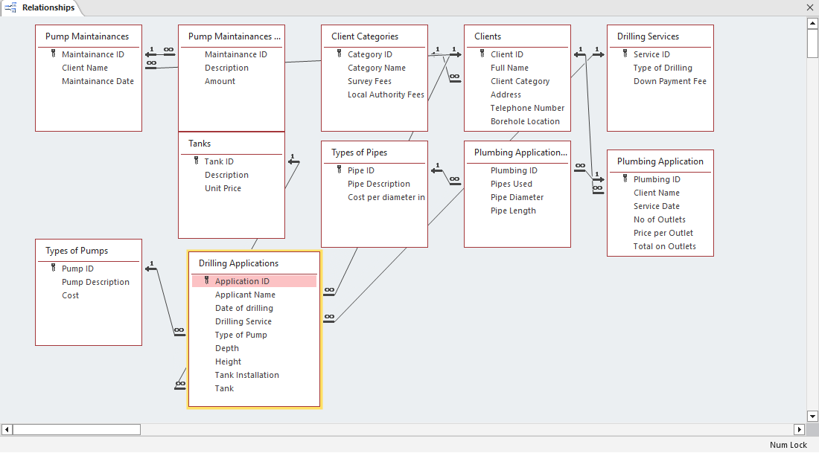

Figure 4.1 Database Relationship

## ENFORCING INTERGRITY CONSTRAINTS

Ensuring data integrity is paramount in any database system to maintain accuracy and consistency of information. This chapter delves into the methods employed to enforce integrity constraints within the computerized database system for Uzima Company's borehole services. It highlights the various constraints applied to maintain the reliability and validity of data, including entity integrity, referential integrity, domain integrity, and user-defined constraints.

### REFERENCIAL INTERGRITY

Referential integrity ensures that a record entered in the related (secondary) table has a matching primary key in the primary table. This is achieved by using a foreign key that create the relationship. Figure 4.2 shows referential integrity between the Clients and Drilling Applications tables.

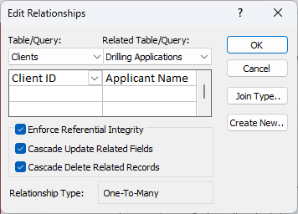

Figure 4.2 Referential Integrity

## Database Tables

### CLIENT’S TABLE

The Client’s table shown in design view below is used to store details of the Company’s clients.

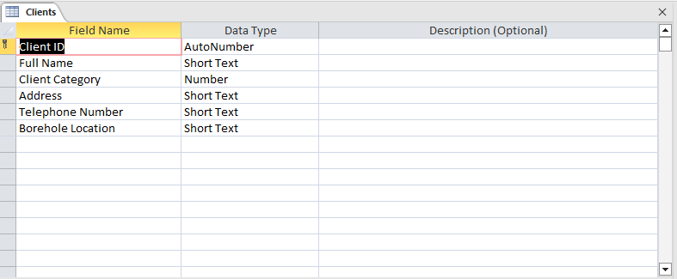

Figure 4.3 Client’s Table

### DRILLING APPLICATIONS

The drilling applications table shown in design view below is used to store details of drilling applications from clients;

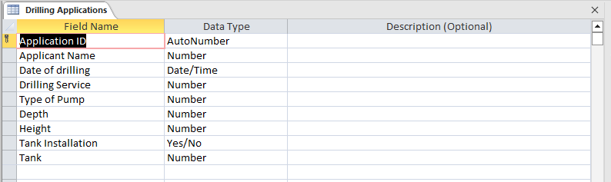

Figure 4.4: Drilling Applications

### PLUMBING APPLICATIONS

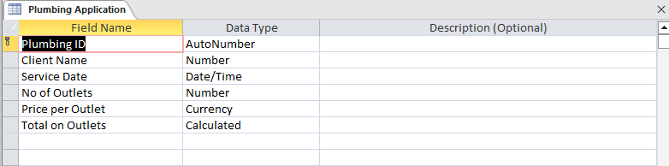

Figure 4.5: Plumbing Applications

### PUMP MAINTENANCE APPLICATIONS

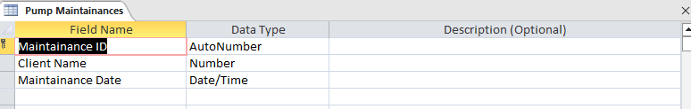

Figure 4.6:Pump Maintenance Applications

## DATABASE QUERIES

In order to combine several tables, we need to create queries that would be used to process various transactions and generate important reports

### Drilling Applications Query

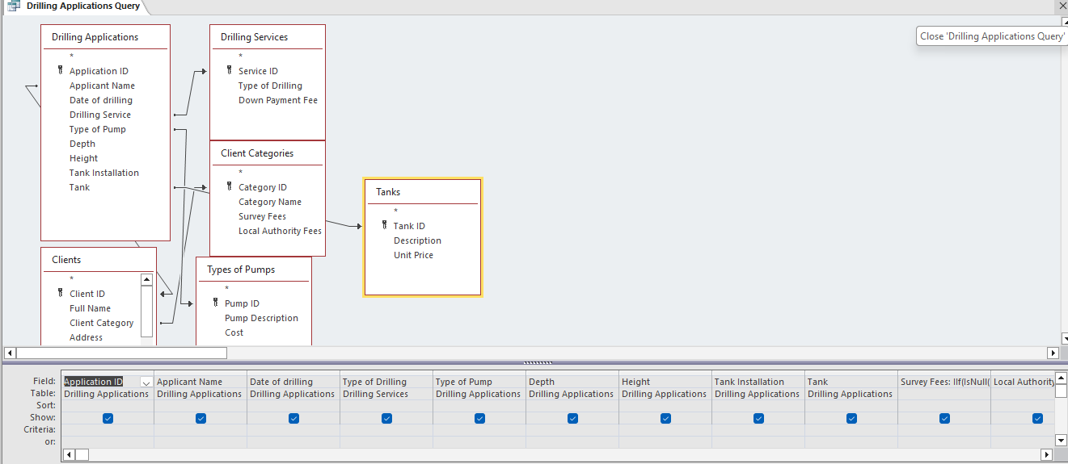

Figure 4.5 Drilling Applications Query

### Plumbing Applications Query

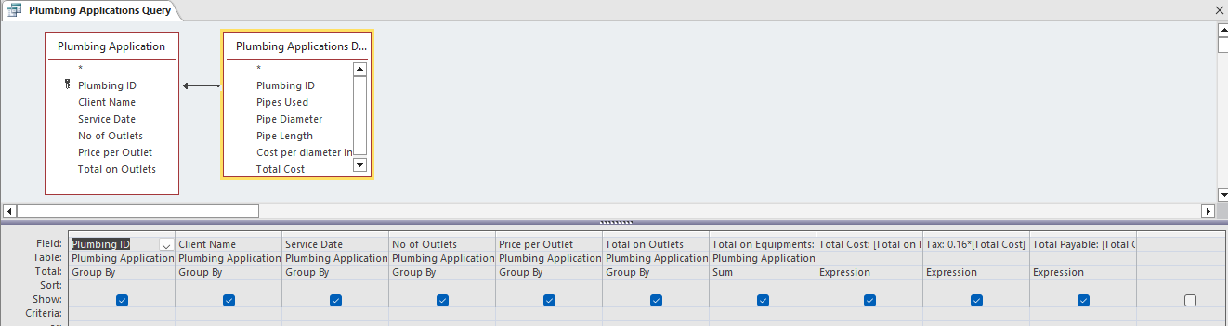

Figure 4.6 Plumbing Applications Query

### Monthly Revenue Query

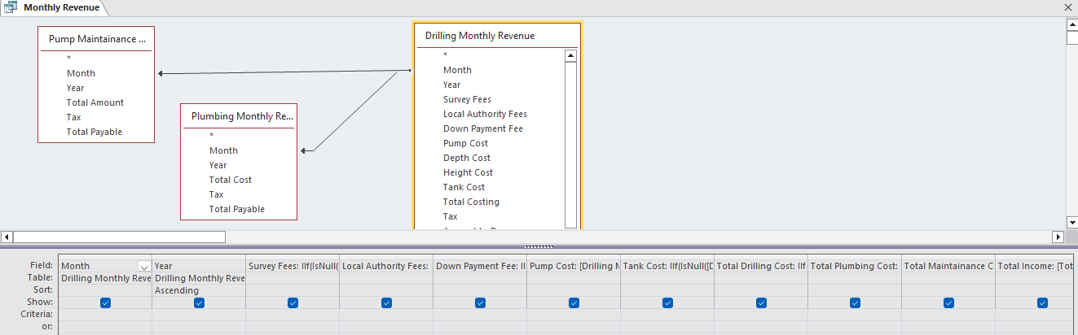

Figure 4.7 Monthly Revenue Query

# USER MANUAL

## INTRODUCTION

The User Manual serves as a comprehensive guide for users interacting with the computerized database system for Uzima Company's borehole services. This chapter provides detailed instructions on how to navigate the system, perform various tasks, and utilize its features efficiently. From client registration to generating reports, users will find step-by-step instructions accompanied by screenshots and explanations to facilitate ease of use and maximize productivity. The User Manual aims to empower users with the knowledge and skills necessary to effectively utilize the system in their daily operations. Let's get started!

### Software Requirements

* + 1. GUI based operating system
    2. Microsoft Access application software from office 2010 or later.
    3. Antivirus software

### Hardware requirements

* + 1. A computerized system
    2. 488-66MHZ processor
    3. At least 170MB of RAM
    4. A compact disk since the software comes on a compact disk
    5. Printers
    6. POS terminal equipment

## HOW TO INSTALL, START AND RUN THE SYSTEM INTERFACE

The system software is copied from the installation disk and pasted in the documents folder. A shortcut icon may be created in the in the desktop. Confirm the presence of a **Microsoft access Software** in the machine. Now click on the icon to launch the system. After opening the system, a screen appears that prompts the user to enable content for first time use. Click on **Enable Content** to terminate.

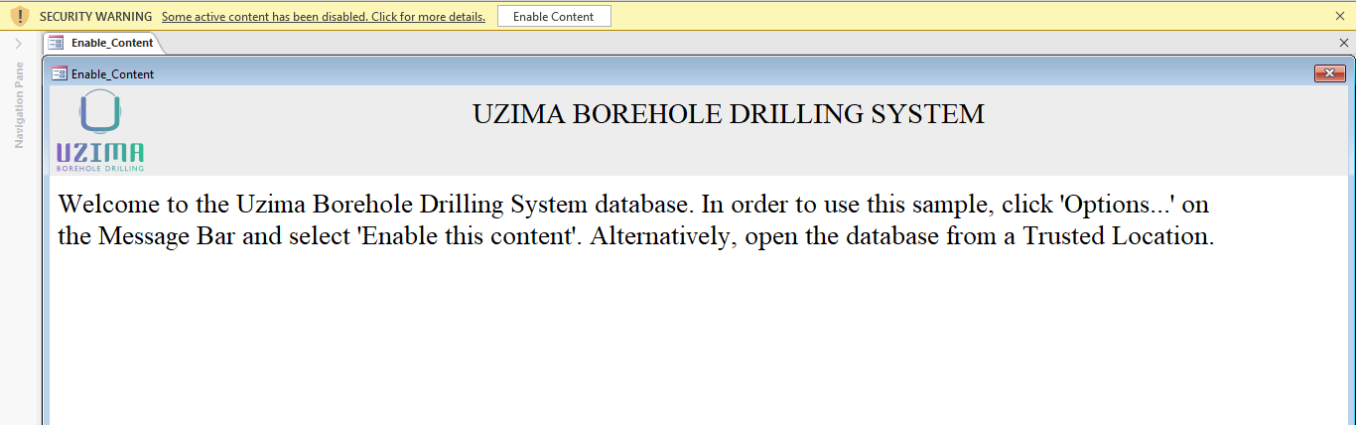

A Startup Screen will appear in which the Program will load its components for approximately 5 seconds. Kindly be patient till the program fully boots as illustrated.

Figure 5.2 Start-up Screen

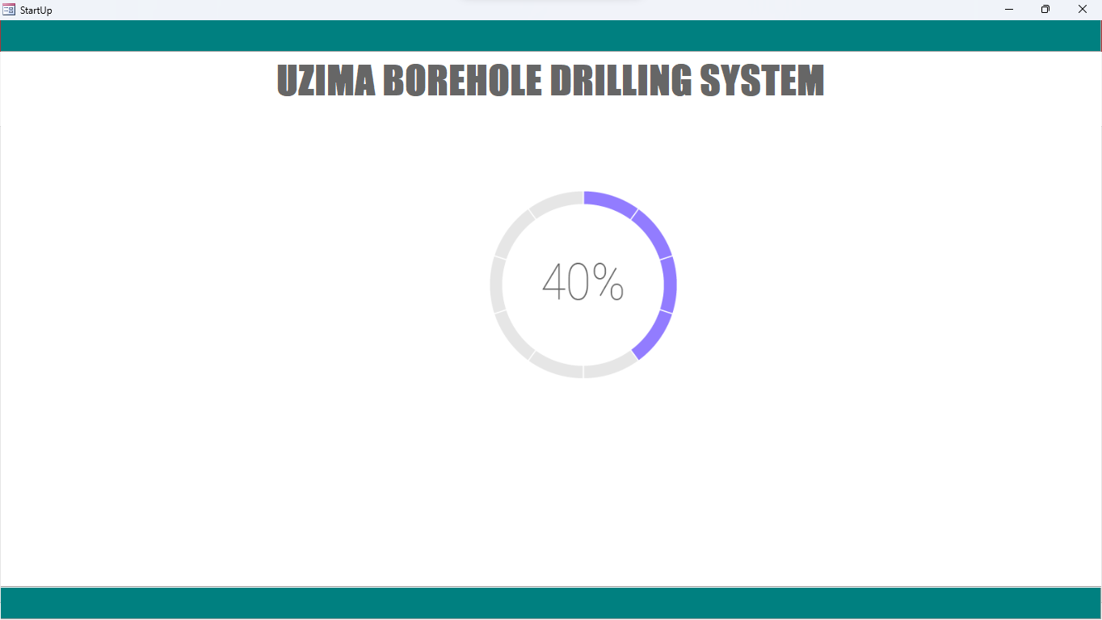

A User log in screen will appear as shown Below:

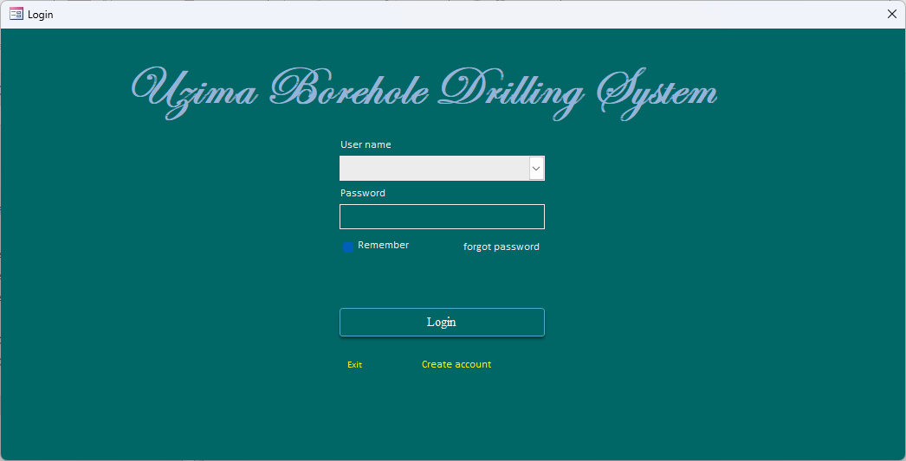

Figure 5.1: Login Screen

## DATA MANIPULATION

During data manipulation, a main home screen is used. This is very user friendly and easy to use. The Home screen looks as shown below. Click on any desired option to launch the required operation.

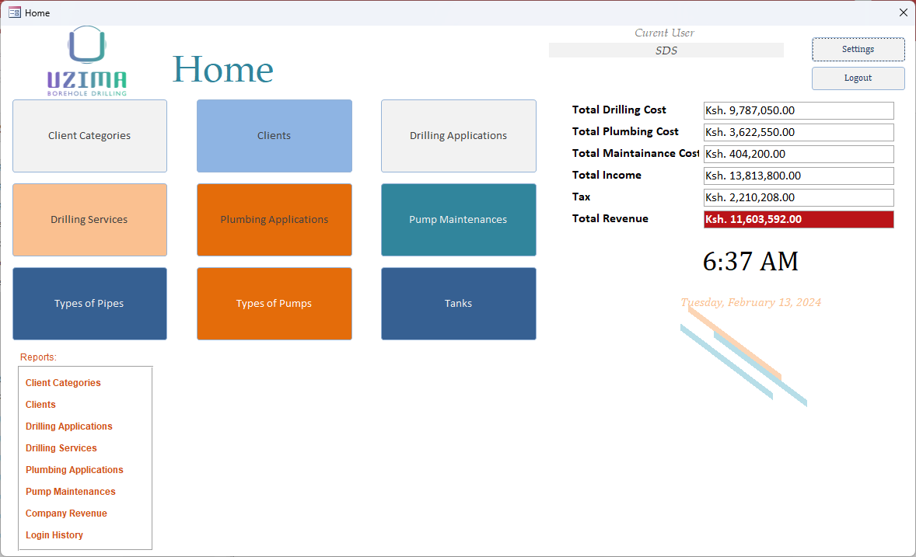

Figure 5.1 Main Switchboard

## NEW MEMBER, ITEM SALES OR EVENTS

### New Client

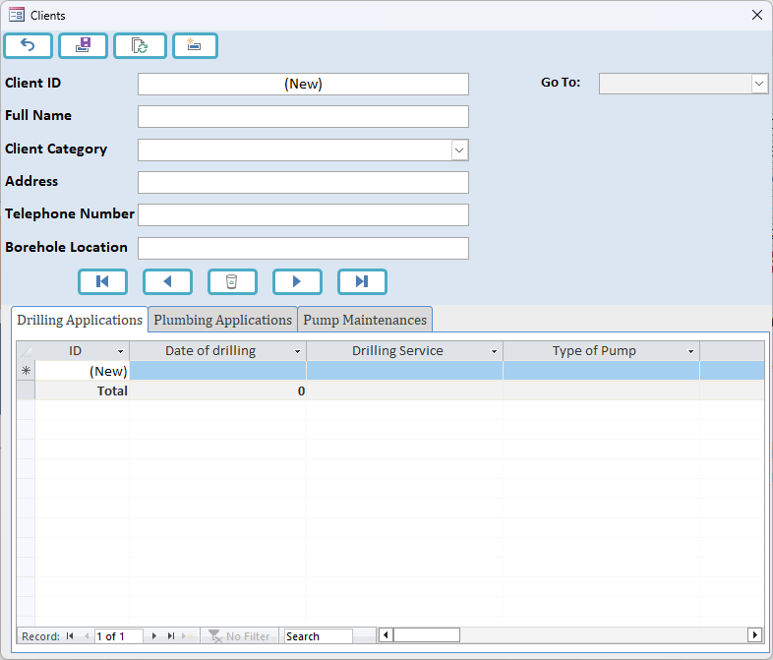

### New Drilling Application

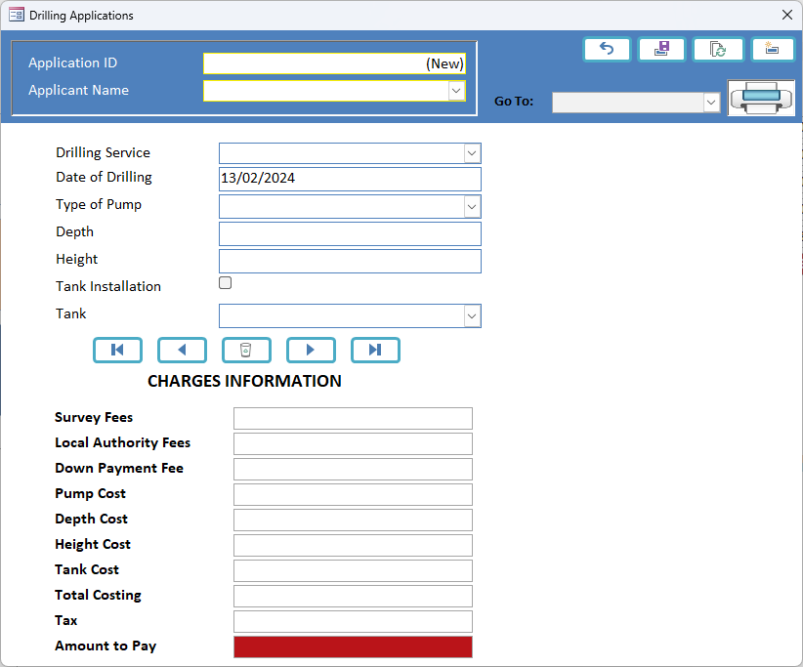

### New Plumbing Application

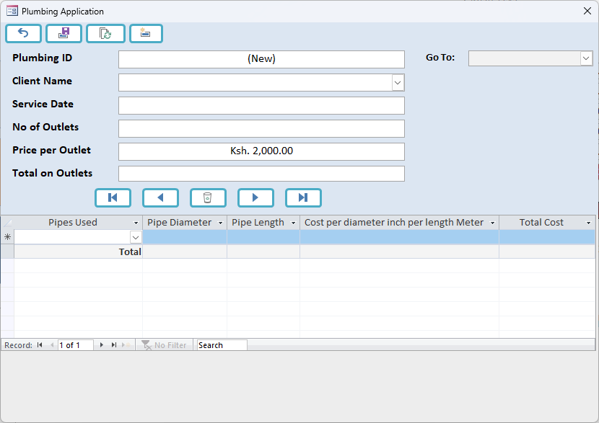

### New Pump Maintenance

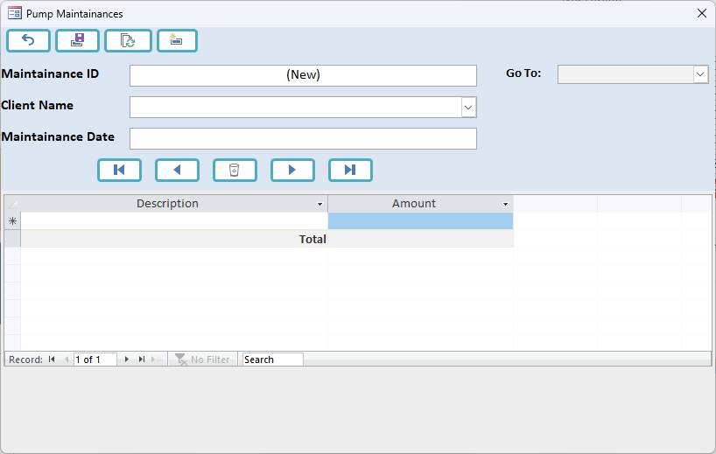

## GENERATING REPORTS

To generate group reports, click on the buttons aligned on the right of the main switchboard as shown below:

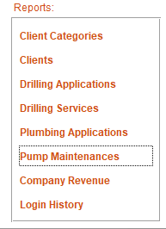

Sample of existing Reports are as shown

### Clients

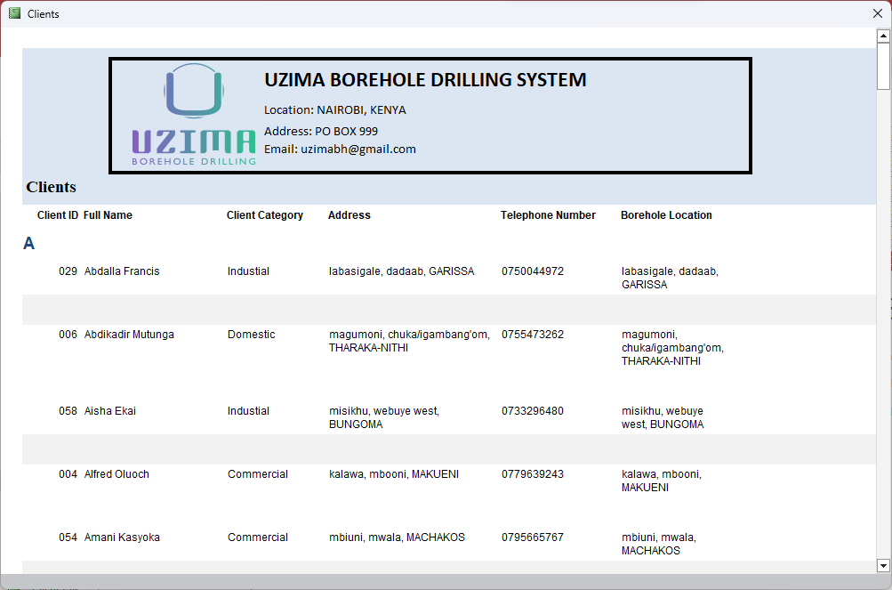

### Drilling Applications

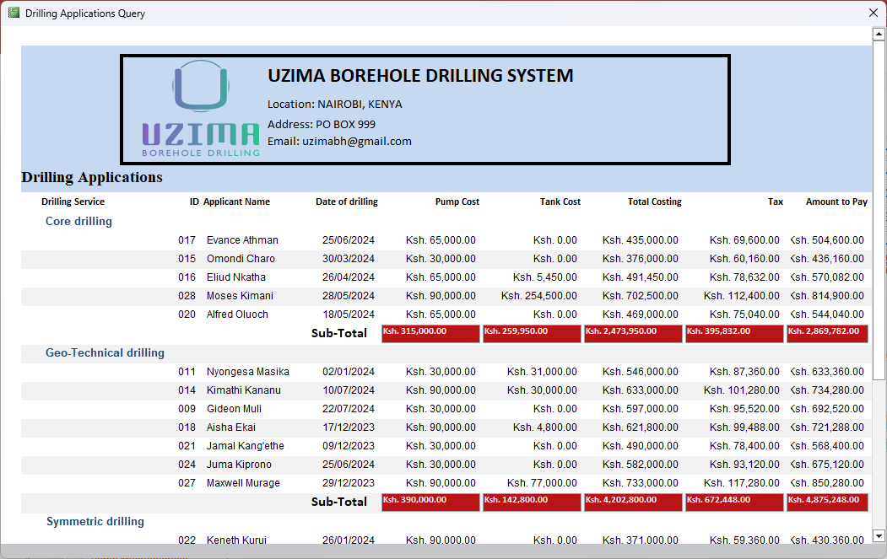

### Plumbing Applications

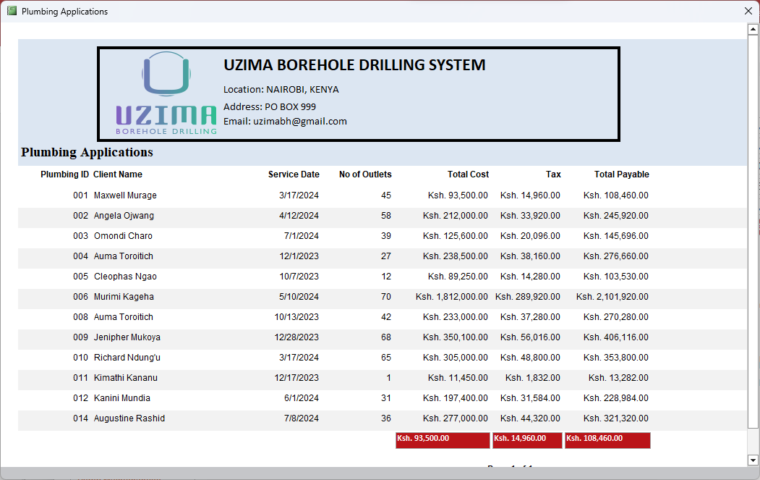

### Pump Maintenances

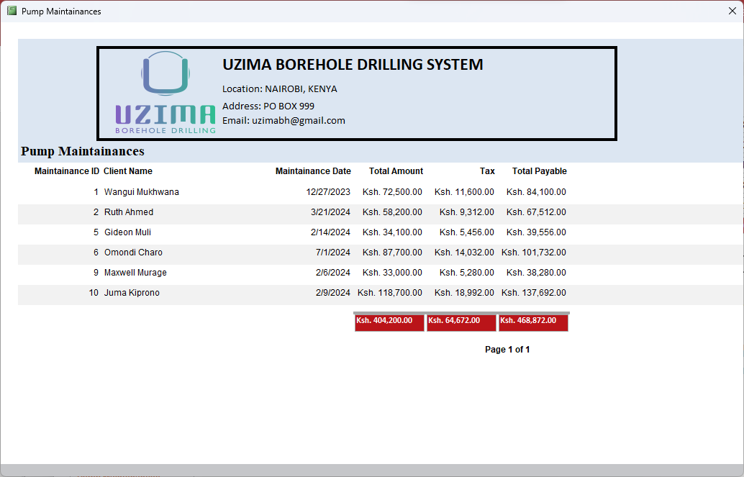

### Clients By Category

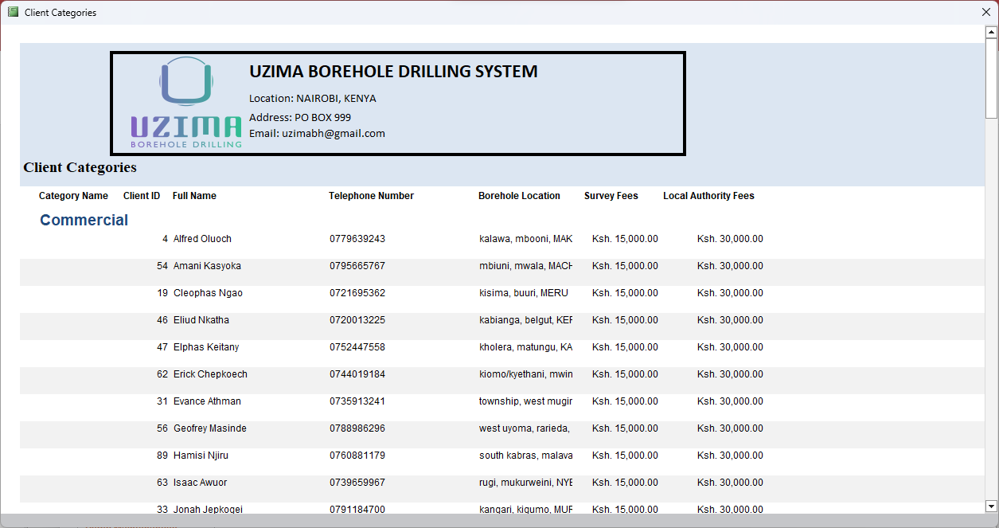

### Club Revenue

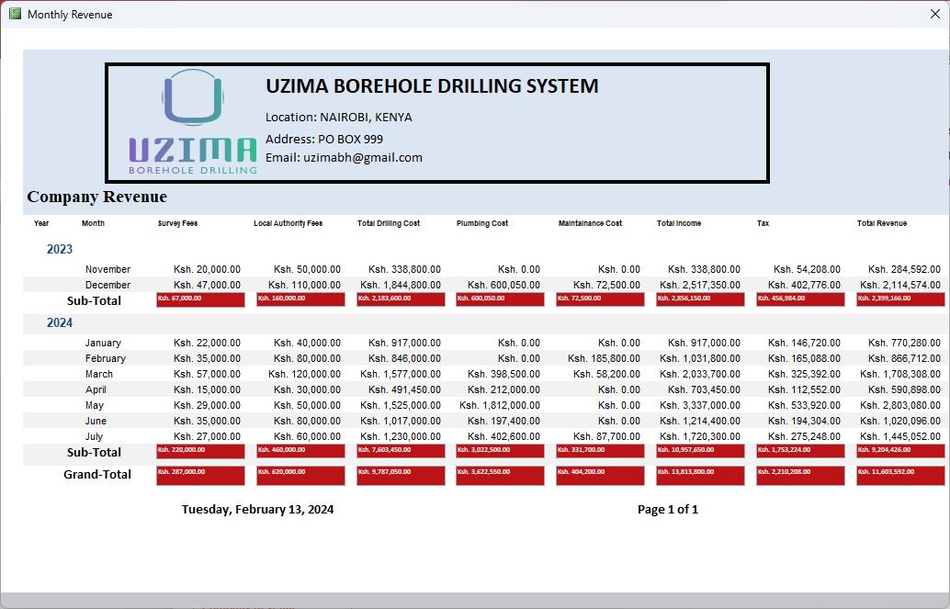

## ADVANCED FEATURES OF THE SYSTEM

The Log In list button shows the details of every user log in and time of log in which is able to track any malicious activities.

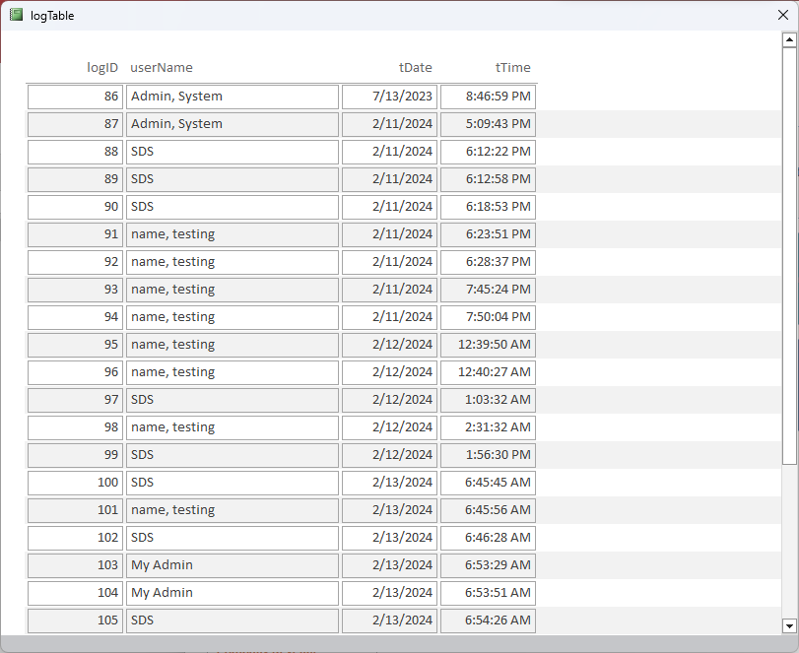

## TROUBLESHOOTING GUIDE

Some small and less harmful errors may occur during the use of the system. They have been carefully tested over a period of time and have been found to cause no harmful damage to the data kept in the system. They can be easily bypassed by clicking OK or YES to accept the permissions.

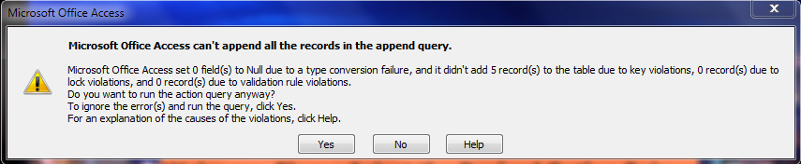

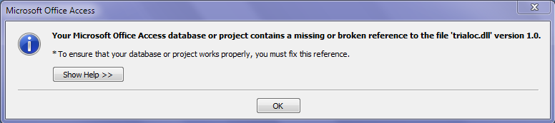

# SYSTEM IMPLIMENTATION

## STAFF TRAINING

Staff training is a crucial component of the system implementation process to ensure smooth adoption and proficient utilization of the computerized database system for Uzima Company's borehole services. The training program is designed to equip staff with the necessary knowledge and skills to effectively navigate the system, input data accurately, generate reports, and troubleshoot common issues.

Training Objectives:

1. Familiarize staff with the system interface and navigation.
2. Train staff on data entry procedures, including client registration and service/item recording.
3. Educate staff on the computation of charges and generating reports.
4. Provide troubleshooting techniques for resolving common system issues.

Training Sessions:

The training sessions will be conducted in a classroom-style environment, facilitated by experienced trainers. Sessions will be interactive, combining theoretical concepts with practical hands-on exercises to reinforce learning. Staff will be divided into small groups to ensure personalized attention and effective learning outcomes.

Training Content:

1. **System Navigation**: Introduction to the system interface, menu structure, and navigation controls.
2. **Data Entry Procedures**: Step-by-step instructions on entering client information, recording services/items provided, and updating records as necessary.
3. **Computation of Charges**: Explanation of the criteria used to calculate charges for services/items, including drilling, pump installation, plumbing, and taxes.
4. **Report Generation**: Demonstrations on generating various reports, such as client information, service charges, tax reports, and revenue summaries.

Training Materials:

* Training manuals and guides.
* Presentation slides.
* Practice datasets for hands-on exercises.
* Troubleshooting FAQs and guides.

Assessment and Feedback:

At the conclusion of each training session, staff will undergo assessments to evaluate their understanding and proficiency in using the system. Feedback will be collected to identify areas for improvement and tailor future training sessions accordingly.

Ongoing Support:

Continuous support will be provided to staff post-training, including access to helpdesk support, additional training sessions as needed, and regular system updates to enhance functionality and address any issues that may arise.

By investing in comprehensive staff training, Uzima Company ensures that its personnel are well-equipped to leverage the full capabilities of the computerized database system, ultimately contributing to increased efficiency, accuracy, and customer satisfaction.

## CHANGE-OVER STRATEGY

The change-over strategy outlines the approach adopted for transitioning from the existing manual or legacy system to the new computerized database system for Uzima Company's borehole services. A well-planned change-over strategy is essential to minimize disruptions, ensure smooth adoption, and maximize the benefits of the new system.

Change-Over Strategy Used: Parallel Adoption

The parallel adoption strategy will be employed for implementing the new computerized database system. This strategy involves running both the old manual system and the new system simultaneously for a certain period to ensure a smooth transition and mitigate risks associated with abrupt system changes.

Rationale for Parallel Adoption:

1. **Risk Mitigation**: Running both systems concurrently allows for comparison and validation of data between the old and new systems, reducing the risk of data loss or inaccuracies during the transition phase.
2. **Training and Familiarization**: Staff have the opportunity to gradually adapt to the new system while still relying on familiar processes of the old system. This minimizes resistance to change and facilitates a smoother transition.
3. **Fallback Option**: In case of any unforeseen issues or challenges with the new system, the old system remains operational as a fallback option, ensuring continuity of operations without major disruptions.

Implementation Steps:

1. **System Configuration and Testing**: Ensure the new computerized database system is properly configured and thoroughly tested to verify its functionality and compatibility with existing processes.
2. **Parallel Run Phase**: During this phase, both the old manual system and the new computerized system will operate simultaneously. Staff will be instructed to input data into both systems to validate consistency and accuracy.
3. **Monitoring and Evaluation**: Continuously monitor the performance of the new system and gather feedback from users regarding any issues or areas for improvement. Regular evaluation will guide adjustments and refinements as needed.
4. **Transition Planning**: Once confidence in the new system is established and users are proficient in its operation, a planned transition will be executed to fully replace the old system with the new one. This may involve data migration, final training sessions, and official decommissioning of the old system.

Communication Plan:

Effective communication is essential throughout the change-over process to keep stakeholders informed and address any concerns. Regular updates, training sessions, and open channels for feedback will be established to facilitate a transparent and collaborative transition.

By employing the parallel adoption strategy and following a structured change-over plan, Uzima Company ensures a seamless transition to the new computerized database system, minimizing disruption to operations and maximizing the benefits of technological advancement.

Top of Form

# SYSTEM REVIEW

## OBJECTIVE APPRAISAL

The objective appraisal involved an evaluation of the computerized database system for Uzima Company's borehole services to assess its performance, effectiveness, and alignment with predefined objectives. This appraisal, conducted post-implementation, aimed to identify strengths, weaknesses, opportunities, and threats associated with the system's functionality and operation.

Evaluation Criteria:

1. **Functionality**: Assessing the system's ability to perform essential tasks such as client registration, service/item recording, charge computation, and report generation accurately and efficiently.
2. **User Experience**: Evaluating the user interface design, ease of navigation, and overall user experience to determine user satisfaction and adoption.
3. **Data Integrity**: Verifying the integrity of data stored within the system, including accuracy, completeness, and consistency, to ensure reliable decision-making.
4. **Performance**: Analyzing the system's performance in terms of speed, responsiveness, and scalability to handle increasing data volumes and user loads effectively.
5. **Adaptability**: Assessing the system's flexibility and ability to accommodate future changes, updates, and enhancements to meet evolving business requirements.

Findings:

1. **Functionality**: The system effectively facilitated client registration, service/item recording, and charge computation according to predefined criteria. Users reported ease of use and efficiency in performing tasks.
2. **User Experience**: Feedback from users indicated high satisfaction with the user interface design and navigation. Training sessions conducted during implementation contributed to user proficiency and comfort with the system.
3. **Data Integrity**: Data integrity checks were implemented successfully, ensuring the accuracy and reliability of information stored within the system. No major issues regarding data integrity were identified during the review.
4. **Performance**: The system demonstrated satisfactory performance in terms of speed and responsiveness, even during peak usage periods. However, minor optimizations may be required to enhance performance as data volumes increase over time.
5. **Adaptability**: The system exhibited adaptability to accommodate minor changes and updates. However, considerations for long-term scalability and integration with future technologies may require further assessment.

Recommendations:

1. **Performance Optimization**: Conduct further performance analysis and optimization measures to ensure continued smooth operation as data volumes grow.
2. **Continuous Training**: Implement ongoing training and support programs to enhance user skills and proficiency, keeping pace with system updates and improvements.
3. **Enhanced Reporting**: Explore options for enhancing reporting capabilities to provide more comprehensive insights and analysis for decision-making purposes.
4. **Future Planning**: Develop a roadmap for future system enhancements and upgrades, considering evolving business needs and technological advancements.

The objective appraisal of the computerized database system for Uzima Company's borehole services reflects overall positive feedback and satisfaction among users. While the system has demonstrated effectiveness and reliability in fulfilling its intended functions, ongoing monitoring and periodic reviews will be essential to address emerging needs and ensure sustained performance and relevance in the dynamic business environment.

## CHALLENGES ENCOUNTERED DURING SYSTEM DEVELOPMENT

The development of the computerized database system for Uzima Company's borehole services was not without its challenges. Throughout the development process, several obstacles were encountered that required careful navigation and problem-solving to overcome. Understanding and addressing these challenges were essential in ensuring the successful implementation of the system.

1. **Complexity of Business Processes**:

Uzima Company's borehole services encompassed a diverse range of processes, including client registration, service/item recording, charge computation, and report generation. Managing the complexity of these processes and ensuring seamless integration within the database system posed a significant challenge during development.

2. **Data Validation and Integrity**:

Ensuring the accuracy and integrity of data inputted into the system was paramount. Developing robust data validation mechanisms to prevent errors, inconsistencies, and unauthorized access proved to be a challenging task, requiring thorough testing and refinement.

3. **Taxation and Fee Calculations**:

The computation of taxes, fees, and charges for services provided involved intricate calculations based on various factors such as client category, service type, depth, and height. Designing algorithms and formulas to accurately calculate these charges while considering different scenarios and exceptions presented a complex challenge during system development.

4. **User Interface Design**:

Creating an intuitive and user-friendly interface was crucial to ensuring user adoption and satisfaction. Balancing functionality with simplicity and aesthetics while catering to the diverse needs of users posed a challenge that required iterative design iterations and user feedback.

5. **Integration with Legacy Systems**:

Integrating the new computerized database system with existing legacy systems and processes within Uzima Company's operations posed compatibility and interoperability challenges. Ensuring seamless data exchange and transition between systems required careful planning and coordination.

6. **Resource Constraints**:

Limited resources, including time, budget, and expertise, posed challenges during system development. Prioritizing tasks, managing timelines, and optimizing resource allocation were essential strategies to overcome these constraints and ensure project success.

7. **Testing and Quality Assurance**:

Thorough testing and quality assurance were critical to identifying and resolving issues before system deployment. Developing comprehensive test cases, conducting rigorous testing, and addressing bugs and inconsistencies required meticulous attention to detail and dedicated effort.

Despite the challenges encountered during system development, the dedicated efforts of the development team, coupled with effective problem-solving strategies and collaboration with stakeholders, enabled the successful implementation of the computerized database system for Uzima Company's borehole services. Documenting these challenges and the strategies employed to overcome them provides valuable insights for future system enhancements and developments.

## STRENGTH OF THE AUTOMATED SYSTEM

The computerized database system developed for Uzima Company's borehole services exhibits several strengths that contribute to its effectiveness, efficiency, and overall value to the organization. Understanding and leveraging these strengths are essential in maximizing the benefits derived from the system and optimizing its contribution to business operations.

1. **Streamlined Processes**:

The automated system streamlines various business processes, including client registration, service/item recording, charge computation, and report generation. By digitizing and centralizing these processes within a unified platform, the system enhances operational efficiency and reduces manual effort and paperwork.

2. **Enhanced Accuracy and Consistency**:

Automation minimizes the potential for human error and ensures greater accuracy and consistency in data entry, calculations, and reporting. Built-in validation mechanisms and predefined algorithms contribute to reliable and error-free processing of information, leading to improved data quality and integrity.

3. **Improved Decision-Making**:

The system provides timely access to accurate and comprehensive data, enabling informed decision-making at various levels within the organization. Real-time reporting and analytics functionalities empower management to gain valuable insights, identify trends, and make strategic decisions to optimize business performance.

4. **Increased Productivity**:

Automating routine tasks and standardizing processes frees up valuable time and resources, allowing staff to focus on more value-added activities. With streamlined workflows and reduced administrative burdens, productivity levels are enhanced, leading to greater output and efficiency across the organization.

5. **Scalability and Flexibility**:

The system is designed to accommodate growth and adapt to evolving business needs. Scalable architecture and flexible configurations enable seamless expansion and customization, ensuring that the system remains relevant and capable of supporting future requirements and innovations.

6. **Enhanced Customer Service**:

By centralizing client information and service records, the system facilitates personalized and responsive customer service. Access to historical data and preferences enables staff to deliver tailored solutions, address customer inquiries promptly, and foster stronger relationships with clients.

7. **Compliance and Audit Trail**:

The system incorporates built-in features to ensure compliance with regulatory requirements and industry standards. Audit trails and data logging functionalities enable traceability and accountability, supporting internal audits and regulatory inspections with ease.

The automated system developed for Uzima Company's borehole services demonstrates several key strengths that contribute to its effectiveness, efficiency, and value proposition. By leveraging these strengths and continuously optimizing system capabilities, Uzima Company can maximize the benefits derived from the system and maintain a competitive edge in the market.

## WEAKNESS OF THE AUTOMATED SYSTEM

While the computerized database system developed for Uzima Company's borehole services offers significant advantages, it also exhibits certain weaknesses that warrant attention and potential mitigation strategies. Understanding these weaknesses is essential in addressing challenges and optimizing the system's performance and effectiveness.

1. **Initial Implementation Costs**:

The initial implementation of the automated system may entail significant upfront costs associated with software development, hardware acquisition, training, and customization. This can pose financial challenges for the organization, especially for small businesses with limited budgets.

2. **Learning Curve for Users**:

Transitioning from manual or legacy systems to an automated system may require staff to acquire new skills and adapt to unfamiliar interfaces and workflows. The learning curve associated with system adoption can lead to temporary decreases in productivity and efficiency during the initial stages.

3. **System Downtime and Technical Issues**:

Like any technological solution, the automated system is susceptible to system downtime, technical glitches, and software bugs. Unforeseen issues such as server crashes, network outages, or software malfunctions can disrupt operations and impact business continuity.

4. **Data Security Risks**:

Centralizing sensitive business data within a computerized system introduces potential security risks, including unauthorized access, data breaches, and cyberattacks. Ensuring robust security measures, such as encryption, access controls, and regular security audits, is essential to mitigate these risks.

5. **Integration Challenges**:

Integrating the new automated system with existing legacy systems, third-party applications, or external data sources may present compatibility and interoperability challenges. Ensuring seamless data exchange and integration between systems requires careful planning and technical expertise.

6. **Maintenance and Upkeep**:

The ongoing maintenance and upkeep of the automated system require dedicated resources, including IT support, software updates, and hardware maintenance. Failure to allocate sufficient resources for system maintenance can lead to performance degradation and system vulnerabilities over time.

7. **Scalability Limitations**:

While the system may be scalable to a certain extent, scaling up to accommodate rapidly growing data volumes or expanding business operations may pose challenges. Ensuring that the system architecture and infrastructure can support future scalability requirements is essential for long-term sustainability.

Conclusion:

Identifying and addressing the weaknesses of the automated system is crucial in optimizing its performance, reliability, and security. By proactively addressing these weaknesses through strategic planning, investment in resources, and ongoing monitoring and improvement efforts, Uzima Company can mitigate risks and maximize the benefits derived from the system.

## RECOMMENDATIONS

Based on the findings from the system review and the identified strengths and weaknesses of the automated system for Uzima Company's borehole services, the following recommendations are proposed to optimize system performance, enhance user experience, and address potential areas for improvement:

1. **Invest in Ongoing Training and Support**:

Continued training and support programs should be implemented to ensure that users are proficient in utilizing the system's features and functionalities effectively. Regular training sessions, refresher courses, and access to user manuals and online resources can enhance user skills and confidence in using the system.

2. **Enhance Data Security Measures**:

Strengthening data security measures, such as implementing multi-factor authentication, encryption protocols, and regular security audits, is essential to safeguard sensitive business data and protect against potential cyber threats and data breaches.

3. **Improve System Performance and Stability**:

Addressing performance bottlenecks, optimizing database queries, and investing in infrastructure upgrades can improve system responsiveness, minimize downtime, and ensure consistent performance, especially during peak usage periods.

4. **Enhance Reporting and Analytics Capabilities**:

Expanding reporting and analytics functionalities to provide more comprehensive insights and analysis can empower management to make informed decisions and identify opportunities for process improvements and business growth.

5. **Streamline Integration with Third-Party Systems**:

Improving integration capabilities with existing legacy systems, third-party applications, and external data sources can enhance data exchange and interoperability, facilitating seamless workflows and information sharing across the organization.

6. **Regular Maintenance and Updates**:

Establishing a proactive maintenance schedule and ensuring timely software updates and patches are applied can mitigate security vulnerabilities, improve system reliability, and extend the lifespan of the automated system.

7. **Monitor and Evaluate System Performance**:

Implementing monitoring tools and performance metrics to track system performance, user satisfaction, and key performance indicators (KPIs) can provide valuable insights for continuous improvement and optimization efforts.

8. **Plan for Future Scalability and Growth**:

Developing a roadmap for future system enhancements, upgrades, and scalability initiatives ensures that the system remains adaptable to evolving business requirements and technological advancements.

Conclusion:

By implementing these recommendations, Uzima Company can maximize the benefits derived from the automated system, mitigate potential risks and challenges, and maintain a competitive edge in the market. Continuously monitoring system performance, gathering user feedback, and iterating on improvements are essential for ensuring the long-term success and sustainability of the automated system.

Top of Form

## CONCLUSIONS

The system review provides valuable insights into the performance, strengths, weaknesses, and areas for improvement of the computerized database system developed for Uzima Company's borehole services. Through a comprehensive evaluation of the system's functionality, usability, and effectiveness, key findings and recommendations have been identified to optimize system performance and maximize its value to the organization.

Key Takeaways:

* The automated system offers significant advantages in streamlining processes, enhancing accuracy, improving decision-making, and increasing productivity.
* Challenges such as initial implementation costs, user learning curves, technical issues, and data security risks highlight areas for attention and improvement.
* Recommendations encompass ongoing training and support, enhancing data security measures, improving system performance and stability, and streamlining integration with third-party systems.

Conclusion:

The computerized database system represents a significant step forward in modernizing Uzima Company's borehole services operations, enhancing efficiency, and facilitating better decision-making. By addressing the identified weaknesses and implementing the recommended improvements, Uzima Company can further leverage the system's strengths to achieve its business objectives, improve customer satisfaction, and maintain a competitive edge in the market. Continuous monitoring, evaluation, and adaptation are essential to ensure the system remains aligned with evolving business needs and technological advancements, driving sustained success and growth for the organization.

Top of Form

## BIBLIOGRAPHY

The bibliography below shows a list of reference materials used in development.

1. Mburu S. & Chemwa G: Mastering Computer Studies; Project, Form 3 and 4 work.
2. Jeffrey L., et al: System Analysis and Design Methods, 5th-Ed, McGraw-Hill.
3. Mburu S. & Chemwa G: Longhorn Secondary Computer Studies Form 4, Longhorn Publishers, Nairobi.
4. Kendal E.K, Kendal J.E: System Analysis and Design, 5th Ed, Prentice-Hall, Kenya.
5. Connolly T and Beg C: Database Systems: A practical Approach to Design, Implementation and Management, 2nd-Ed Addison Wesley.

# APPENDIX

Ksh – Kenya Shillings

RAM – Random Access Memory

TB – Tera Byte

SQL – Structured Query Language

GB - Gigabyte